DAY 01:
# Today I learnt the some basic cloud computing and AWS concepts.
- Wt is could computing ?
Cloud computing means using computing resources such as servers, storage, databases, and networking over the internet instead of buying and maintaining our own physical computers.
Ex: Earlier, if a company wanted to build a website, It had to: Buy physical servers, Install operating systems, Set up networking, Maintain hardware
Today, with AWS, we can rent these resources online and pay only for what we use.
- Wt is AWS(Amazon web Services)?
It’s a could platform provided by Amazon. Its offers more then 200 cloud services like..Virtual Servers, Storage, Databases, Networking, Artificial Intelligence, Security
Many big companies like Netflix, Airbnb, Samsung, Adobe, and startups use AWS because it is reliable, secure, and scalable.
# Benefits of Cloud Computing
Pay as You Go: We only pay for the resources we use.
Scalability: Resources can be increased or decreased based on demand.
High Availability: Services continue running even if one data center experiences an issue.
Security: AWS provides high security features such as encryption and identity management.
Global Access: Applications can be deployed in different countries using AWS Regions.
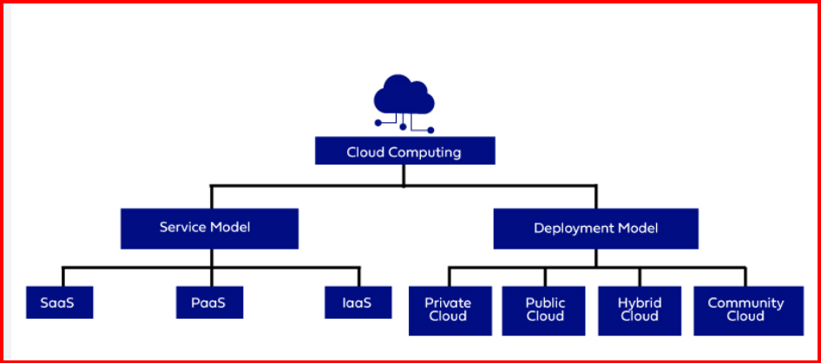
Cloud Service Models:
IaaS (Infrastructure as a Service) : AWS provides virtual servers, storage, and networking. The Customers install their own operating systems and applications . For Example: Amazon EC2
PaaS (Platform as a Service) : AWS provides both the infrastructure and platform. Developers only focus on writing code.

SaaS (Software as a Service) : Ready to use software accessed through the internet. No installation or server management is required. for Examples: Gmail, Microsoft 365

Type of cloud (deployment model):

1. Public Cloud: Resources are owned and managed by cloud providers like AWS.
Example: AWS ,Microsoft Azure, Google Cloud.. Most companies use the Public Cloud.
2. Private Cloud: Infrastructure is dedicated to a single organization. Used when companies need higher security and complete control. For Example: Banks and government organizations.

3. Hybrid Cloud : A combination of Public Cloud and Private Cloud. Sensitive data remains in the Private Cloud while other applications run in the Public Cloud. Many large enterprises use this model .
4.Cummunity cloud: A Community Cloud is a cloud infrastructure shared by a group of organizations that have similar needs, security requirements, or business objectives. For example: Suppose five hospitals need to securely store and share patient records.

AWS Global Infrastructure : A Region is a physical geographical location where AWS has multiple data centers for Examples: Mumbai ,North Virginia ,Singapore, London

Availability Zone (AZ): Each Region contains multiple Availability Zones. An Availability Zone is one or more data centers with independent power, cooling, and networking. If one Availability Zone has a problem, applications can continue running in another AZ. This provides high availability and fault tolerance

Edge Locations: Edge Locations are smaller AWS sites located closer to users.They are mainly used to deliver content faster using Amazon CloudFront. This helps reduce latency and improves application performance.

AWS free Tier : AWS provides a Free Tier that allows beginners to learn cloud services without paying for many common resources, as long as they stay within the free usage limits.

